**Custom Layout Website**

**Web design is the application of ideas, technology, and visual design to passionately convey your brand's personality online. The end result is a customer expense that achieves your business goals.**

**Who should have a Layout Website?**

If you own a business that advertises to attract new customers, you need a website. More people will see your website than will see your advertising, Facebook page, business card or storefront. Things have changed out there. People still want what you sell, but now they go to Google find it. Google’s free, but you still have to be found. Even when you are found, you have to have a great website or your would-be customer will click off and go look at another site. You’ve done it. We’ve done it. People are very visual and if something doesn’t look good, they won’t waste time looking at it. Layouts come with five pages to start and are expandable. Additional pages are only $100 each. Can’t tell how many pages you’ll need? Give us a call.

**What do we get?**

Custom Layout Design is built on a site model, meaning that *you’ll always see your site before it’s built!*  This is a huge plus, because you’ll know what you are getting before we even begin.

* Home, About, Products, Services and Contact pages
* Domain and Hosting
* Themed to match your business type
* Your logo, your images, your message
* Professionally written by sales copywriters
* Use of Advanced and Innovative methods like ToolTip & Lightbox Technology
* Contact section allows a message to be sent right from the site
* Ready to integrate with PayPal or your favorite payment method

We keep our overheads low and our processes efficient. We know when a new, professional photo is needed and when an almost-free stock shot is even better. Our designers are as fast as they are innovative. You get the savings

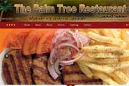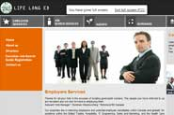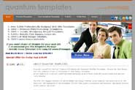

**www.thepalmtreerestaurant.com www.lifelonged.ca www.q-templates.com**